Scientists have been collecting data on solar storms and it’s effects on the earth for years. The data collected include flow speed (km/s), plasma density (cm-3), temperature (K), Na/Np ratio [ratio of Helium nuclei to protons], plasma beta [the relationship between the plasma pressure and the magnetic pressure], and SymH [a number that signifies the effect of the solar storm on the earth]. The Na/NP ratio is a direct measure of the composition differences and indicates source regions of the solar storm. If the plasma beta is higher than 1, it means there is more thermal pressure and if it is lower than 1, it means there is more magnetic pressure. The more negative SymH is, the larger the storm is and the more damage it will deal.

Two types of storms have been identified with high and low storm speeds seeming to be identifying factors. To further analyze, I have seperated the data collected by storm speed. Values higher than 530 km/s are identified as fast and values lower than 430 km/s are identified as slow. Values between 430 and 530 are not included as they possibly contain data from both types of storms. The graphic below displays the collected data values seperated by storm speed. These are values over time, represented by the index number (x axis) in which they were stored and therefore the order in which the data was collected. The purpose is to show that different storm speeds also tend to have different values in some of the categories (y axis). For example, slow storms seem to have a higher density value while fast storms seem to have a lower density value (2nd plot). Faster storms seem to reach higher temperature values while slow storms seem to have lower temperature values (3rd plot). Finally, slower storms seem to have more thermal pressure while fast storms seem to have more magnetic pressure (5th plot).

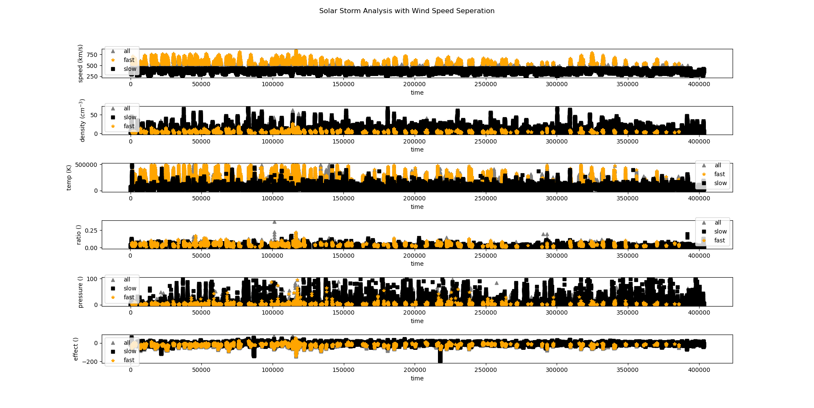

Let’s dig a bit deeper. While keeping the flow speed seperation, we can use a 2d histogram to compare the temperature ( y axis) and the effect (x axis) of the two types of storms. The graph below shows that fast storms not only tend to have more of an effect (the further the value is from zero the higher the effect) but also tend to have a higher temperature. The slow storms seem to have less of an effect (the value tends to be closer to zero) and they also seem to have a lower temperature.

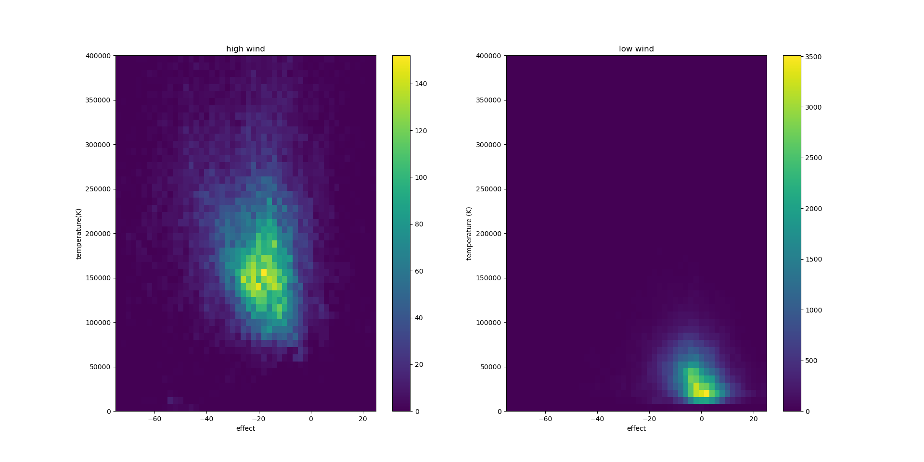

What we can conclude from this analysis is that fast storms tend to be hotter, tend to have a lower density and pressure, and have more of an effect on the Earth on average. Slow storms tend to not be as hot, have a higher density and pressure, and have less of an effect on the Earth on average.